

Compensation and Pension Record Interchange (CAPRI)

Eating Disorders

Disability Benefits Questionnaire (DBQ)

Workflow

February 2011

Department of Veterans Affairs
Office of Enterprise Development
Management & Financial Systems

Revision History

Date | Description (Patch # if applicable) | Author
9/30/10 | Document created for Patch 161. | C. Gawronski
2/22/11 | Corrections and revisions | M. Guthrie

Table of Contents

1 Introduction 1
1.1 Purpose 1
1.2 Overview 1
2 Eating Disorders DBQ – History Tab 2
2.1 Name of patient/Veteran 2
2.2 Section 1. Diagnosis 5
2.3 Section 2. Medical history 8
2.4 Section 3. Findings 8
2.5 Section 4. Other symptoms 11
2.6 Section 5. Functional impact 12
2.7 Section 6. Remarks, if any 13
3 Eating Disorders AMIE-DBQ Worksheet 14

Table of Figures and Table

Table 1: Rules: DBQ – Eating Disorders – Name of patient/Veteran 3
Table 2: Rules: DBQ – Eating Disorders – 1. Diagnosis 6
Table 3: Rules: DBQ – Eating Disorders – 2. Medical history 8
Table 4: Rules: DBQ – Eating Disorders – 3. Findings 9
Table 5: Rules: DBQ – Eating Disorders – 4. Other symptoms 11
Table 6: Rules: DBQ – Eating Disorders – 5. Functional impact 12
Table 7: Rules: DBQ – Eating Disorders – 6. Remarks, if any 13

Figure 1: Template Example: DBQ – Standard VA Note 1
Figure 2: Print Example: DBQ – Standard VA Note 1
Figure 3: Template Example: DBQ – Eating Disorders – Name of patient/Veteran 4
Figure 4: Print Example: DBQ – Eating Disorders – Name of patient/Veteran 4
Figure 5: Template Example: DBQ – Eating Disorders – 1. Diagnosis 7
Figure 6: Print Example: DBQ – Eating Disorders – 1. Diagnosis 7
Figure 7: Template Example: DBQ – Eating Disorders – 2. Medical history 8
Figure 8: Print Example: DBQ – Eating Disorders – 2. Medical history 8
Figure 9: Template Example: DBQ – Eating Disorders – 3. Findings 10
Figure 10: Print Example: DBQ – Eating Disorders – 3. Findings 10
Figure 11: Template Example: DBQ – Eating Disorders – 4. Other symptoms 11
Figure 12: Print Example: DBQ – Eating Disorders – 4. Other symptoms 11
Figure 13: Template Example: DBQ – Eating Disorders – 5. Functional impact 12
Figure 14: Print Example: DBQ – Eating Disorders – 5. Functional impact 12
Figure 15: Template Example: DBQ – Eating Disorders – 6. Remarks, if any 13
Figure 16: Print Example: DBQ – Eating Disorders – 6. Remarks, if any 13

Introduction

Purpose
This document provides a high level overview of the contents found on the EATING DISORDERS Disability Benefits Questionnaire (DBQ). The DBQ can be populated via an online template within the CAPRI C&P Worksheets tab and then printed OR it can be printed via AMIE and then manually populated. This document contains the edit rules for the template as well as examples of how the template will look online in CAPRI or printed from CAPRI. It also contains the layout for the AMIE worksheet to depict how it will look when printed from AMIE.

For more detailed information on standard template functionality not covered in this document, please refer to the C&P Worksheet Tab Functionalities section of the CAPRI GUI User Guide.

Overview
The EATING DISORDERS DBQ provides the ability to capture information related to Eating Disorders and their treatment.

Each DBQ template contains a standard footer containing a note stating that “VA may request additional medical information, including additional examinations if necessary to complete VA’s review of Veteran’s application.” (see Figure 1 and 2).

Figure 1: Template Example: DBQ – Standard VA Note
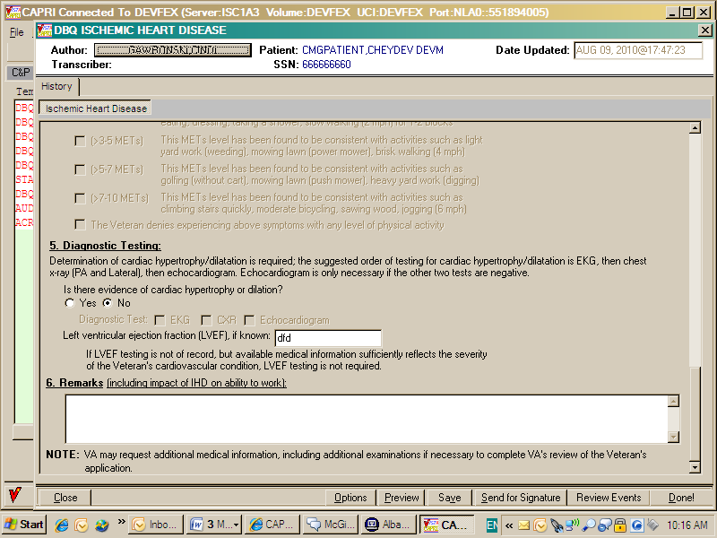

Figure 2: Print Example: DBQ – Standard VA Note

NOTE: VA may request additional medical information, including additional

examinations if necessary to complete VA's review of the Veteran's application.

A number of fields on the EATING DISORDERS template are mandatory and require a response (value) prior to the exam being marked as completed. Some questions may activate a Pop-up window displaying information as to each question that needs to be answered before the template can be completed.

Eating Disorders DBQ – History Tab

Name of patient/Veteran
All questions in this section must be answered as described by the rules below. If all mandatory questions are not answered, the error message(s) will appear in a popup window displaying the error message described below.

Table 1: Rules: DBQ – Eating Disorders – Name of patient/Veteran
Field/Question | Field Disposition | Valid Values | Format | Error Message
Disability Benefits Questionnaire | Disabled, Read-Only | N/A | N/A | N/A
Eating Disorders | Disabled, Read-Only | N/A | N/A | N/A
Name of patient/Veteran | Enabled, Mandatory | N/A | Free Text | Please enter the name of the patient/Veteran.
Your patient is applying to the U. S. Department of Veterans Affairs (VA) for disability benefits. VA will consider the information you provide on this questionnaire as part of their evaluation in processing the Veteran’s claim. | Disabled, Read-Only | N/A | N/A | N/A
NOTE: If the Veteran experiences a mental health emergency during the interview, please terminate the interview and obtain help, using local resources as appropriate. You may also contact the VA Suicide Prevention Hotline at 1-800-273-TALK. Stay on the Hotline until help can link the Veteran to emergency care. | Disabled, Read-Only | N/A | N/A | N/A
NOTE: In order to conduct an examination for eating disorders, the examiner must meet one of the following criteria: a board-certified or board-eligible psychiatrist; a licensed doctorate-level psychologist; a doctorate-level mental health provider under the close supervision of a board-certified or board-eligible psychiatrist or licensed doctorate-level psychologist; a psychiatry resident under close supervision of a board-certified or board-eligible psychiatrist or licensed doctorate-level psychologist; or a clinical or counseling psychologist completing a one-year internship or residency (for purposes of a doctorate-level degree) under close supervision of a board-certified or board- eligible psychiatrist or licensed doctorate-level psychologist.  In order to conduct a REVIEW examination for eating disorders, the examiner must meet one of the criteria from above, OR be a licensed clinical social worker (LCSW), a nurse practitioner, a clinical nurse specialist, or a physician assistant, under close supervision of a board-certified or board-eligible psychiatrist or licensed doctorate-level psychologist. | Disabled, Read-Only | N/A | N/A | N/A

Figure 3: Template Example: DBQ – Eating Disorders – Name of patient/Veteran
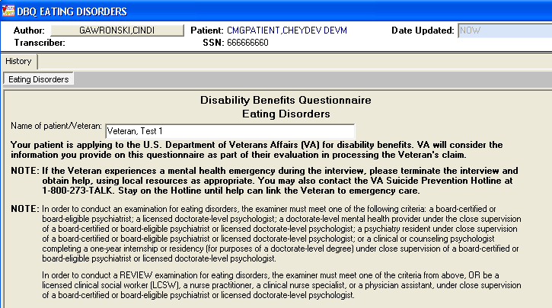

Figure 4: Print Example: DBQ – Eating Disorders – Name of patient/Veteran
Disability Benefits Questionnaire
Eating Disorders
Name of patient/Veteran: Veteran, Test 1
Your patient is applying to the U.S. Department of Veterans Affairs (VA)
for disability benefits. VA will consider the information you provide on this
questionnaire as part of their evaluation in processing the Veteran's claim.
NOTE: If the Veteran experiences a mental health emergency during the
interview, please terminate the interview and obtain help, using local
resources as appropriate. You may also contact the VA Suicide Prevention
Hotline at 1-800-273-TALK. Stay on the Hotline until help can link the
Veteran to emergency care.
NOTE: In order to conduct an examination for eating disorders, the
examiner must meet one of the following criteria: a board-certified or
board-eligible psychiatrist; a licensed doctorate-level psychologist; a
doctorate-level mental health provider under the close supervision of a
board-certified or board-eligible psychiatrist or licensed doctorate-level
psychologist; a psychiatry resident under close supervision of a board-
certified or board-eligible psychiatrist or licensed doctorate-level
psychologist; or a clinical or counseling psychologist completing a one-
year internship or residency (for purposes of a doctorate-level degree)
under close supervision of a board-certified or board-eligible
psychiatrist or licensed doctorate-level psychologist.
In order to conduct a REVIEW examination for eating disorders, the
examiner must meet one of the criteria from above, OR be a licensed
clinical social worker (LCSW), a nurse practitioner, a clinical nurse
specialist, or a physician assistant, under close supervision of a board-
certified or board-eligible psychiatrist or licensed doctorate-level
psychologist.

Section 1. Diagnosis
The question “Does the Veteran now have or has he/she ever been diagnosed with an eating disorder(s)?” must be answered before the template can be completed.

- If it is answered with Yes, all other questions requiring an answer as described by the rules in this document must be answered before the template can be completed.
- If it is answered with No, the rationale for this is required. The remainder of the template may be completed without answering any additional questions or the user may input answers to any of the optional questions as indicated by the rules described in this document.

All questions will be printed even if they have not been answered.

If all mandatory questions are not answered, the error message(s) will appear in a popup window as depicted below and must be answered before this template can be completed.

Table 2: Rules: DBQ – Eating Disorders – 1. Diagnosis
Field/Question | Field Disposition | Valid Values | Format | Error Message
1.Diagnosis | Disabled, Read-Only | N/A | N/A | N/A
Does the Veteran now have or has he/she ever been diagnosed with an eating disorder(s)? | Enabled, Mandatory, Choose one valid value | [Yes; No] | N/A | Please answer the question: Does the Veteran now have or has he/she ever been diagnosed with an eating disorder(s)?
If no, provide rationale (e.g., Veteran does not currently have any diagnosed eating disorders): | If Diagnosis = No; Enabled, Mandatory  Else; Disabled | N/A | Free Text | Please provide the rationale for stating the Veteran has never been diagnosed with an eating disorder.
If yes, check all diagnoses that apply: | If Diagnosis = Yes; Enabled, Mandatory, Choose one or more valid values  Else; Disabled | [Bulimia; Anorexia;  Eating disorder not otherwise specified] | N/A | Please select at least one diagnosed eating disorder.
Date of diagnosis: | If Bulimia = Yes; Enabled, Mandatory  Else; Disabled | N/A | Free Text | Please enter a value in the date of diagnosis field for bulimia.
ICD code: | If Bulimia = Yes; Enabled, Mandatory  Else; Disabled | N/A | Free Text | Please enter the ICD code for bulimia.
Name of diagnosing facility or clinician: | If Bulimia = Yes; Enabled, Mandatory  Else; Disabled | N/A | Free Text | Please enter the name of the diagnosing facility or clinician for bulimia.
Date of diagnosis: | If Anorexia  = Yes; Enabled, Mandatory  Else; Disabled | N/A | Free Text | Please enter a value in the date of diagnosis field for anorexia.
ICD code: | If Anorexia = Yes; Enabled, Mandatory  Else; Disabled | N/A | Free Text | Please enter the ICD code for anorexia.
Name of diagnosing facility or clinician: | If Anorexia = Yes; Enabled, Mandatory  Else; Disabled | N/A | Free Text | Please enter the name of the diagnosing facility or clinician for anorexia.
Date of diagnosis: | If Eating disorder not otherwise specified = Yes; Enabled, Mandatory  Else; Disabled | N/A | Free Text | Please enter a value in the date of diagnosis field for the eating disorder not otherwise specified.
ICD code: | If Eating disorder not otherwise specified = Yes; Enabled, Mandatory  Else; Disabled | N/A | Free Text | Please enter the ICD code for eating disorder not otherwise specified.
Name of diagnosing facility or clinician: | If Eating disorder not otherwise specified = Yes; Enabled, Mandatory  Else; Disabled | N/A | Free Text | Please enter the name of the diagnosing facility or clinician for eating disorder not otherwise specified.

Figure 5: Template Example: DBQ – Eating Disorders – 1. Diagnosis
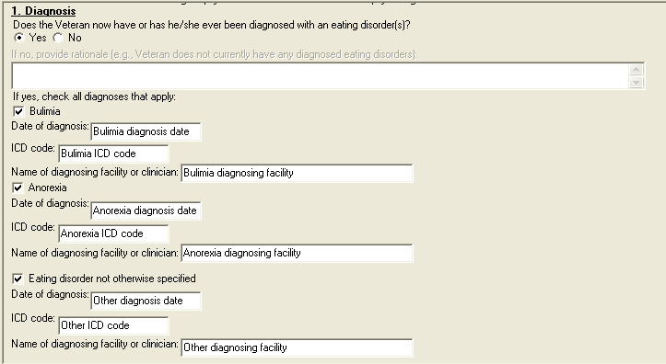

Figure 6: Print Example: DBQ – Eating Disorders – 1. Diagnosis
1. Diagnosis
------------
Does the Veteran now have or has he/she ever been diagnosed with an
eating disorder(s)? [X] Yes [ ] No
If no, provide rationale (e.g., Veteran does not currently have any
diagnosed eating disorders):
If yes, check all diagnoses that apply:
[X] Bulimia
Date of diagnosis: Bulimia diagnosis date
ICD code: Bulimia ICD code
Name of diagnosing facility or clinician: Bulimia diagnosing facility
[X] Anorexia
Date of diagnosis: Anorexia diagnosis date
ICD code: Anorexia ICD code
Name of diagnosing facility or clinician: Anorexia diagnosing facility
[X] Eating disorder not otherwise specified
Date of diagnosis: Other diagnosis date
ICD code: Other ICD code
Name of diagnosing facility or clinician: Other diagnosing facility

Section 2. Medical history
All questions in this section may be answered as described by the rules below. If all mandatory questions are not answered, the error message(s) will appear in a popup window displaying the error message depicted below.

Table 3: Rules: DBQ – Eating Disorders – 2. Medical history
Field/Question | Field Disposition | Valid Values | Format | Error Message
2.Medical history | Disabled, Read-Only | N/A | N/A | N/A
Describe the history (including onset and course) of the Veteran’s eating disorder (brief summary): | If Diagnosis = Yes; Enabled, Mandatory  Else; Enabled, Optional | N/A | Free Text | Please describe the history, including onset and course, of the Veteran's eating disorder.

Figure 7: Template Example: DBQ – Eating Disorders – 2. Medical history


Figure 8: Print Example: DBQ – Eating Disorders – 2. Medical history
2. Medical history
------------------
Describe the history (including onset and course) of the Veteran's
eating disorder (brief summary): <history>

Section 3. Findings
All questions in this section may be answered as described by the rules below. If all mandatory questions are not answered, the error message(s) will appear in a popup window displaying the error message depicted below.

Table 4: Rules: DBQ – Eating Disorders – 3. Findings
Field/Question | Field Disposition | Valid Values | Format | Error Message
3.Findings | Disabled, Read-Only | N/A | N/A | N/A
NOTE: For VA purposes, an incapacitating episode is defined as a period during which bedrest and treatment by a physician are required. | Disabled, Read-Only | N/A | N/A | N/A
N/A | If Diagnosis = Yes; Enabled, Choose one Valid Value  Else; Enabled, Optional | [Binge eating followed by self-induced vomiting or other measures to prevent weight gain, or resistance to weight gain even when below expected minimum weight, with diagnosis of an eating disorder but without incapacitating episodes;  Binge eating followed by self-induced vomiting or other measures to prevent weight gain, or resistance to weight gain even when below expected minimum weight, with diagnosis of an eating disorder and incapacitating episodes of up to two weeks total duration per year;  Self-induced weight loss to less than 85 percent of expected minimum weight with incapacitating episodes of more than two but less than six weeks total duration per year;  Self-induced weight loss to less than 85 percent of expected minimum weight with incapacitating episodes of six or more weeks total duration per year;  Self-induced weight loss to less than 80 percent of expected minimum weight, with incapacitating episodes of at least six weeks total duration per year, and requiring hospitalization more than twice a year for parenteral nutrition or tube feeding] | N/A | Please check one item in section 3.
Figure 9: Template Example: DBQ – Eating Disorders – 3. Findings
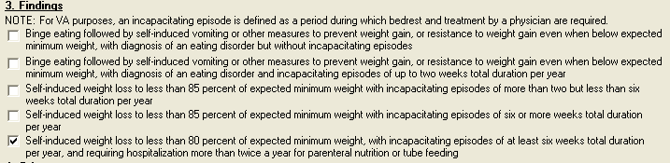

Figure 10: Print Example: DBQ – Eating Disorders – 3. Findings
3. Findings
-----------
NOTE: For VA purposes, an incapacitating episode is defined as a period
during which bedrest and treatment by a physician are required.
[ ] Binge eating followed by self-induced vomiting or other measures to
prevent weight gain, or resistance to weight gain even when below expected
minimum weight, with a diagnosis of an eating disorder but without
incapacitating episodes
[ ] Binge eating followed by self-induced vomiting or other measures to
prevent weight gain, or resistance to weight gain even when below expected
minimum weight, with a diagnosis of an eating disorder and incapacitating
episodes of up to two weeks total duration per year
[X] Self-induced weight loss to less than 85 percent of expected minimum
weight with incapacitating episodes of more than two but less than six
weeks total duration per year
[ ] Self-induced weight loss to less than 85 percent of expected minimum
weight with incapacitating episodes of six or more weeks total duration
per year
[ ] Self-induced weight loss to less than 80 percent of expected minimum
weight, with incapacitating episodes of at least six weeks total duration
per year, and requiring hospitalization more than twice a year for
parenteral nutrition or tube feeding

Section 4. Other symptoms

All questions in this section may be answered as described by the rules below. If all mandatory questions are not answered, the error message(s) will appear in a popup window displaying the error message depicted below.

Table 5: Rules: DBQ – Eating Disorders – 4. Other symptoms
Field/Question | Field Disposition | Valid Values | Format | Error Message
4. Other symptoms | Disabled, Read-Only | N/A | N/A | N/A
Does the Veteran have any other symptoms attributable to an eating disorder? | If diagnosis = Yes; Enabled, Mandatory, Choose one valid value  Else; Enabled, Optional | [Yes; No] | N/A | Please answer the question: Does the Veteran have any other symptoms attributable to an eating disorder?
If yes, describe: | If Does the Veteran have any other symptoms attributable to an eating disorder = Yes; Enabled, Mandatory  Else; Disabled | N/A | Free Text | Please describe any other symptoms attributable to an eating disorder.

Figure 11: Template Example: DBQ – Eating Disorders – 4. Other symptoms
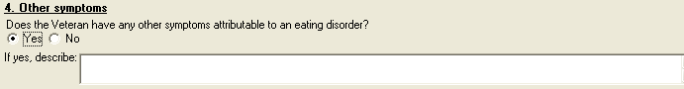

Figure 12: Print Example: DBQ – Eating Disorders – 4. Other symptoms
4. Other symptoms
-----------------
Does the Veteran have any other symptoms attributable to an eating
disorder?
[X] Yes [ ] No
If yes, describe: Other Symptoms Go Here

Section 5. Functional impact
All questions in this section may be answered as described by the rules below. If all mandatory questions are not answered, the error message(s) will appear in a popup window displaying the error message depicted below.

Table 6: Rules: DBQ – Eating Disorders – 5. Functional impact
Field/Question | Field Disposition | Valid Values | Format | Error  Message
5. Functional Impact | Disabled, Read only | N/A | N/A | N/A
Does the Veteran’s eating disorder(s) impact his or her ability to work? | If diagnosis = Yes; Enabled, Mandatory, Choose one value  Else; Enabled, Optional | [Yes; No] | N/A | Please answer the question: Does the Veteran's eating disorder(s) impact his or her ability to work?
If yes, describe impact, providing one or more examples: | If preceding question = Yes; Enabled, Mandatory  Else; Disabled | N/A | Free Text | Please describe the impact of the eating disorder(s) on the Veteran's ability to work, providing one or more examples.

Figure 13: Template Example: DBQ – Eating Disorders – 5. Functional impact
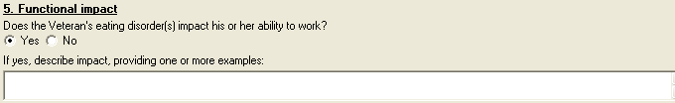

Figure 14: Print Example: DBQ – Eating Disorders – 5. Functional impact
5. Functional impact
--------------------
Does the Veteran's eating disorder(s) impact his or her ability to
work?
[X] Yes [ ] No
If yes, describe impact, providing one or more examples: Functional
Impact Goes Here

Section 6. Remarks, if any
All questions in this section may be answered as depicted by the rules below.

Table 7: Rules: DBQ – Eating Disorders – 6. Remarks, if any
Field/Question | Field Disposition | Valid Values | Format | Error  Message
6. Remarks, if any | Enabled, Optional | N/A | Free Text | N/A

Figure 15: Template Example: DBQ – Eating Disorders – 6. Remarks, if any


Figure 16: Print Example: DBQ – Eating Disorders – 6. Remarks, if any
6. Remarks, if any
------------------
Remarks go here

Eating Disorders AMIE-DBQ Worksheet
The AMIE-DBQ worksheets are accessed via the [DVBA C PRINT BLANK C&P WORKSHE] Print Blank C&P Worksheet DBQ EATING DISORDERS (MENTAL DISORDERS) menu option.

Disability Benefits Questionnaire
Eating Disorders

Name of patient/Veteran: _______________________ SSN: ________________

Your patient is applying to the U. S. Department of Veterans Affairs
(VA) for disability benefits. VA will consider the information you
provide on this questionnaire as part of their evaluation in processing
the Veteran's claim.

NOTE: If the Veteran experiences a mental health emergency during the
interview, please terminate the interview and obtain help, using local
resources as appropriate. You may also contact the VA Suicide Prevention
Hotline at 1-800-273-TALK. Stay on the Hotline until help can link the
Veteran to emergency care.

NOTE: In order to conduct an examination for eating disorders, the examiner
must meet one of the following criteria: a board-certified or board-eligible
psychiatrist; a licensed doctorate-level psychologist; a
doctorate-level mental health provider under the close supervision of a
board-certified or board-eligible psychiatrist or licensed doctorate-level
psychologist; a psychiatry resident under close supervision of a board-
certified or board-eligible psychiatrist or licensed doctorate-level
psychologist; or a clinical or counseling psychologist completing a one-year
internship or residency (for purposes of a doctorate-level degree) under
close supervision of a board-certified or board-eligible psychiatrist or
licensed doctorate-level psychologist.

In order to conduct a REVIEW examination for eating disorders, the examiner
must meet one of the criteria from above, OR be a licensed clinical social
worker (LCSW), a nurse practitioner, a clinical nurse specialist, or a
physician assistant, under close supervision of a board-certified or board-
eligible psychiatrist or licensed doctorate-level psychologist.

1. Diagnosis

Does the Veteran now have or has he/she ever been diagnosed with an eating
disorder(s)?

___ Yes ___ No

If no, provide rationale (e.g., Veteran does not currently have any
diagnosed eating disorders): _______________________________________________

If yes, check all diagnoses that apply:

___ Bulimia

Date of diagnosis: ____________________

ICD code: __________

Name of diagnosing facility or clinician: ______________________________

Page: 2

Disability Benefits Questionnaire for
Eating Disorders

___ Anorexia

Date of diagnosis: ____________________

ICD code: __________

Name of diagnosing facility or clinician: ______________________________
___ Eating disorder not otherwise specified

Date of diagnosis: ____________________

ICD code: __________

Name of diagnosing facility or clinician: ______________________________

2. Medical History

Describe the history (including onset and course) of the Veteran's eating
disorder (brief summary):
_____________________________________________________________________________

3. Findings

NOTE: For VA purposes, an incapacitating episode is defined as a period
during which bedrest and treatment by a physician are required.

___ Binge eating followed by self-induced vomiting or other measures to
prevent weight gain, or resistance to weight gain even when below
expected minimum weight, with diagnosis of an eating disorder but
without incapacitating episodes
___ Binge eating followed by self-induced vomiting or other measures to
prevent weight gain, or resistance to weight gain even when below
expected minimum weight, with diagnosis of an eating disorder and
incapacitating episodes of up to two weeks total duration per year
___ Self-induced weight loss to less than 85 percent of expected minimum
weight with incapacitating episodes of more than two but less than
six weeks total duration per year
___ Self-induced weight loss to less than 85 percent of expected minimum
weight with incapacitating episodes of six or more weeks total duration
per year
___ Self-induced weight loss to less than 80 percent of expected minimum
weight, with incapacitating episodes of at least six weeks total
duration per year, and requiring hospitalization more than twice a year
for parenteral nutrition or tube feeding

Page: 3

Disability Benefits Questionnaire for
Eating Disorders

4. Other symptoms

Does the Veteran have any other symptoms attributable to an eating disorder?

___ Yes ___ No

If yes, describe: _________________________________________________________

5. Functional impact

Does the Veteran's eating disorder(s) impact his or her ability to work?

___ Yes ___ No

If yes, describe impact, providing one or more examples: ___________________

____________________________________________________________________________

6. Remarks, if any _________________________________________________________

____________________________________________________________________________

Psychiatrist/Psychologist/examiner signature & title: ______________________

Psychiatrist/Psychologist/examiner printed name: ___________________________

Date: ________________________ Phone: ____________________________________

License #: _____________

Psychiatrist/Psychologist/examiner address: ________________________________

____________________________________________________________________________

NOTE: VA may request additional medical information, including additional
examinations if necessary to complete VA's review of the Veteran's
application.

